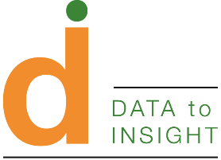

Data to Insight: Structure and Governance
V1.2 (December 2022)

Contents
- Context
- Data to Insight’s governance arrangements
  - Formation
  - Structure
  - Governance
  - Portability
- Funding and finance records
- Changes to these terms of reference
- Further reference
- Appendices
  - Original (project) arrangements, 2021-22
  - Current board membership
  - Major expenditure to date (funded by D2I)
  - Funding partners to date (providing funding to D2I)
  - Other interested parties

- Context
Data to Insight (D2I) is a national project designed by local authorities and supported by the ADCS, DfE, DLUHC and Ofsted, helping local authorities make better use of data. With a primary focus on children's social care and ambition to extend support to other targeted children’s services, D2I support a national community of data professionals in designing, developing and maintaining useful data tools, connecting like-minded people, and helping good practice spread across regional boundaries. We want every local authority to have great ways of working with data, because high quality data work is crucial in enabling our services to effectively support children.
D2I enhances a proven partnership of LAs working together for the sector. Our depth and breadth of expertise and community reach gives data projects the best chance possible of succeeding in producing meaningful insight.
As the fixed term project develops into a long-term service, it’s important to ensure that all partners can have clear understanding of how things will work, and how the service will remain resilient into the future. This paper outlines the project’s provenance, its original governance arrangements (mostly informal), and new formal governance arrangement to suit the long-running service we hope D2I will become with support from regional funding sources.
We will use 2022 to negotiate the long term future of Data to Insight as an LA-led collaboration and service. We will establish the structure and governance arrangements we feel meet the needs of the ongoing service. This work will be led by the existing board, seeking as much input as possible from the regional partnerships with whom we hope to agree our long term funding approach. Final arrangements will be presented to CS-NPIMG as the convening-point of the nine regional groups, as well as to the nine regional groups themselves.

- Data to Insight’s governance arrangements

  - Formation
Data to Insight is a successful project. As such we have adopted long term arrangements which build on the project structure and governance, introducing missing pieces such as succession planning and conflict resolution, as opposed to replacing the existing core framework.
With that said, what suited a project may not suit a long-running service. A project board does not necessarily need a succession plan, but a service does. A project with one employee can be hosted by an LA with a low level of scrutiny and assurance; a larger team may need more formal arrangements with its host, or alternative approaches to managing resources. Below we outline arrangements we think serve the interests of all partners in the service.
  - Structure
Data to Insight (D2I) is hosted by a Local Authority (currently East Sussex County Council as part of the South East Sector Led Improvement Partnership (SESLIP) on behalf of all local safeguarding authorities in England.
The Local Authority:
- Employees all D2I staff
- Provides workforce services to those staff commensurate with those provided to all other employees
- Provides service support to D2I as a service commensurate with that provided to all other internal services
- Supports D2I in holding a distinct budget, and managing that budget in line with internal standards
- Agrees a fixed rate of remuneration from D2I in return for the provision of the above services
- Grants D2I control of D2I’s activities, without interference, so long as those activities do not risk harm to the Local Authority’s reputation or its activities
- Provides D2I with a named contact who can advise and support on the management of the above operations
- Undertakes to provide D2I with at least 12 months’ notice of termination of the hosting arrangement
D2I takes direction from its own formal board of non-executive volunteer directors. The board will continue to issue direction based on feedback from local authorities, the CS-NPIMG, its partner regional groups, and colleagues at ADCS. D2I will report regularly to all such partners, including providing avenues for meaningful feedback.
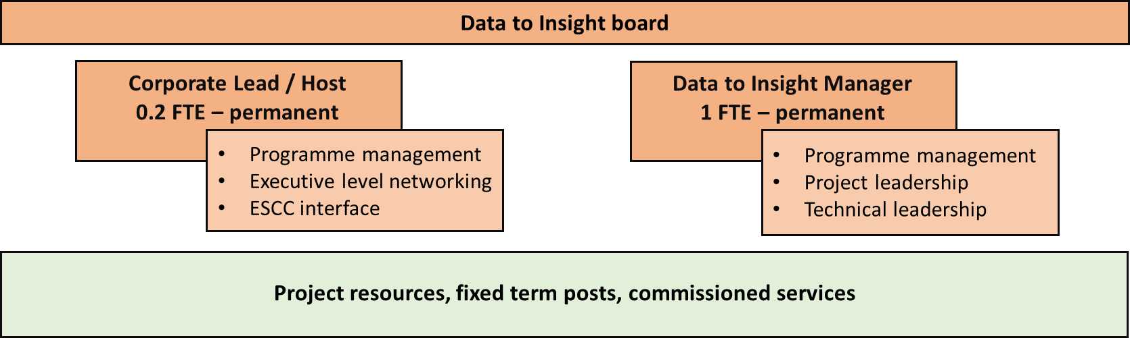

D2I as a service is compartmentalised away from the LA structure as much as possible, to make it “portable” between LAs if needed.
Structure within D2I is flexible according to the normal ebb and flow of funding, but D2I will maintain a permanent management resource to govern this. D2I retains reserves against possible redundancy of any D2I employee. Should the service or its management resource prove financially unsustainable, the project will dissolve as an entity hosted by the LA, returning to its prior status as a community collaboration under CS-NPIMG. This is to protect the host LA against negative consequences from hosting the service without funding.
(Long term funding partners will be formalised during 2022, and relationships established to ensure funding transfer mechanisms exist between partners and the host LA. Most such mechanisms are already in place with the current host LA, following receipt of Recovery Fund monies from regional partnerships.)
  - Governance
D2I as a functional unit is governed by an independent board, chaired by the Data to Insight Manager and formed of six non-executive volunteer directors – currently the six founding members of the project established in 2020.

The Data to Insight Manager’s purpose is to:
- Lead the Data to Insight service on behalf of local authority data professionals
- Own day-to-day decision-making for the service
- Decide when to involve the board in day-to-day decision-making
- Convene the board for regular board meetings, and own any consequent actions
- Engage all other stakeholders in service delivery and decision-making as appropriate
- Manage, develop and deliver the service, its projects, products and community links
- Work with funding partners to bring agreed funding into the service
- Work with the host LA to spend agreed funding as directed by the board and stakeholders
- Work with the board and host LA to ensure the service complies with all legal, regulatory and professional frameworks appropriate to a local government collaborative function hosted by a local authority

The board’s purpose is to:
- Own the strategic vision and goals for the service
- Convene for regular board meetings to review service activity and identify future actions
- Define service strategy and review high-level goals on a regular basis
- Advise the Data to Insight Manager on all matters pertaining to running the service
- Assess the performance of the service and identify any necessary remedial actions to ensure success
- Recruit to the board, and to the post of the Data to Insight Manager, when necessary
- Work with their organisations and partners to promote the service

Board membership:
The board comprises:
- Three Local Authority (LA) partners (representing CS-NPIMG)
- Three non-Local Authority partners
- The service’s current executive officer
The three LA partners represent Local Authority leadership of D2I. The three “non-LA partners” represent central government, regional partnerships, and non-profit/commercial expertise. This balance of membership ensures that D2I benefits from breadth of perspective, but that the partnership of individual LAs retains the strongest focus in discussion and decision-making.

Replacing board members

We note the following principles of board membership:
- Board membership is held by individuals and not by organisations
- There is no maximum term on board membership
- There is no payment for board membership, either to the individual or their employing organisation
- Should a board member for any reason be unable or unsuitable to contribute to the board, this will trigger a selection process to identify a new board member (this process will differ slightly depending on whether the exiting member is an LA partner or a non-LA partner)
- Board members may step down at any time
- Board members may vote to remove another board member should that partner’s continuing involvement seem to harm, or risk harming, proper delivery of the D2I service
Appointment is at the discretion of the board and the board may choose the duration of any gap between appointments, and the nature of any interim governance arrangements or assessment/interview process.
Potential replacements will be invited based both on merit and suitability, and with consideration for the balance of skills, experience and professional links represented by existing board members.
For LA partners, the remaining board members will seek to recruit a replacement board member from the wider community of local authority data professionals. If the new board member is not already a member of CS-NPIMG, D2I will request their inclusion in future CS-NPIMG meetings and communications.
For non-LA partners, the remaining board members will seek to recruit a replacement board member from the wider community with a view to ensuring the board retains a broad focus encompassing regional, central government, and commercial perspectives as far as possible.
Should an LA partner leave LA employment and commence a role with a non-LA employer, they will stand down from the board (unless there exists a suitable vacancy for a non-LA partner, or a suitable non-LA partner opts to stand down in order to create such a vacancy), and a new LA partner will be selected.
New individuals will be invited to join as associate directors for two meeting cycles. After this, they can be appointed as a permanent director by mutual agreement between individual and board. Should the board and the individual agree to continue the relationship, the new individual will become a full and equal board member from their third meeting onwards. We recognise that some individuals may find that board membership doesn’t work for them, and equally that the board may wish not to appoint the new director. In either case, we hope that any parting will be amicable.

The above refers to meetings actually attended by the individual – any absence will extend the period of associate directorship. More details follow below.

A note on diversity and representation:
We recognise that our founders cannot fully represent the broad diversity of cultural background and lived experience either of our immediate professional community or the children and young people who are the ultimate end users of the work we do.
While appointment to the board will always be made with a focus on finding the best person to augment our pre-existing range of skills and experiences, we will work as part of those considerations to ensure that we neither exclude any potential member unfairly, nor allow our service to be poorly directed due to narrow representation.
In our context this is not only a question of protected characteristics, but also considerations like partners’ locations and organisation types. The national picture is wide; local authorities vary widely in nature, and while D2I began in the South East of England and values the strength of community it finds in the South East and London, we will work to help a broader range of viewpoints find their way into our decision-making over time.

Conflict resolution and decision making:
To date the board has disagreed often, but never reached an impasse. We see formal decision making and conflict resolution frameworks as a last resort to ensure our work can proceed. These are terms which have not to date proved necessary, but which we feel are important to clarify against the possibility of future need.
In the event of a serious irreconcilable difference of opinion as to a particular point of action, decision will be reached by an open vote made during the next board meeting. With seven board members, the Data to Insight Manager will make a casting vote if necessary. If all three LA partners are in agreement, the Data to Insight Manager will vote in agreement with the LA partners.
All board members will work to support decisions reached in this manner, as they would any other board decision.
Input from financial stakeholders (LAs, regional partnerships):
D2I will report quarterly to NPIMG as the convening point of the nine regional performance groups, inviting feedback and challenge to inform the board’s direction (which board, as noted above, includes at least 3 NPIMG members).
D2I will report quarterly to each regional performance group which invites D2I to do so, either by formal report or regional meeting attendance.
D2I will share its reporting with RIIA / SLI leads in each region and invite feedback from RIIA / SLI leads in accordance with each region’s preference.
D2I will maintain open communication channels with other key partners through its board members and professional relationships, notably ADCS, Ofsted, DfE (Data Directorate), and DLUHC (Local Digital Collaboration Unit). Feedback from these partners is very welcome, though decision-making will continue to be owned by the board and LAs.

Input from other stakeholders (users, contributors, suppliers):
D2I maintains open communication platforms for users and contributors, enabling them to engage according to their preference. Users communicate feedback via email, Slack, or in meetings. D2I prioritises feedback.
“Suppliers” is a broad category. D2I is open to interaction with any other partners, insofar as those interactions do not risk actual or reputational harm either to the interests of D2I or the host LA. However D2I maintains no commitment to engage or provide any service to any partner other than those identified by name above.

  - Portability
The above arrangements are intended both to represent a stable long-term model for D2I and to ensure that the model can function with minimal oversight from the host LA and minimal reliance on the host LA. We recognise that local priorities and structures change over time and that we may need to move D2I to another host at some future date, through no fault of D2I or the current host LA. By making the service a self-contained functional entity, we seek to make that transfer process as straightforward as possible for all parties.
In identifying a new host, the board will consider the current context of the work and possible hosts, and approach potential colleague informally in the first instance. As the cost of hosting D2I is small to the host LA (estimated to be less than £10k/year), D2I’s selection of a new host should not need a full procurement process, though D2I will be guided in this by the requirements of its current host and any prospective host. Though it is convenient for the host to be a board member this will not be essential. D2I hosting is not an opportunity for profit, but a service performed on behalf of other LAs for which D2I provides appropriate remuneration.

- Funding and finance records
D2I maintains financial records split by funding source and will make these available to partners via the same channels noted above for other collaborative purposes, as appropriate. For a summary, see appendices C and D.

- Changes to these terms of reference
These terms of reference can be changed by majority vote of the board. Colleagues and partners are encouraged to recommend improvements and amendments where they see fit, and the executive officer will consider these for recommendation to the board.

- Further reference
To get in touch about anything to do with Data to Insight, email datatoinsight.enquiries@gmail.com

- Appendices
Appendix A: Original (project) governance arrangements, 2020-21
- Formation
DfE funded D2I in April 2020 to maintain the existing tools (ChAT and Social Care Benchmarking Tool), develop the community, identify and promote new tools developed by the community, and set up an apprenticeship to upskill the CSD analyst community. To date, this work has surpassed expectations among community members. Our “First year retrospective” report details our successes so far.
- Structure
Data to Insight was a project with a mix of funding sources (all public sector to date), established within the South East Sector Led Improvement Partnership (SESLIP) on behalf of all local safeguarding authorities in England, with staffing and other resources hosted by East Sussex County Council (ESCC).
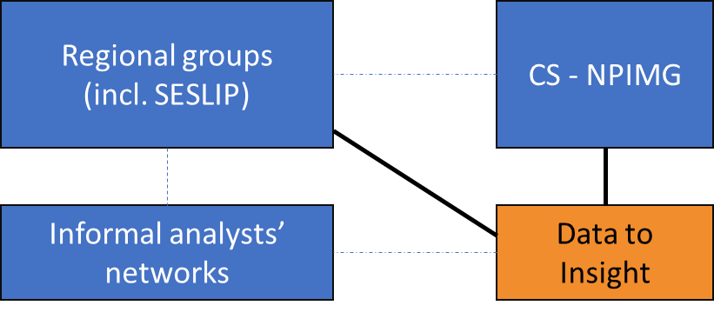
Formal links therefore existed both to SESLIP and to the CS-NPIMG which represents the regional groups (and by extension all local authorities) across England. Informal links existed to individual LAs and analysts via various networks, projects and interactions.
Data to Insight drew funding via SESLIP into ESCC as well as directly into ESCC and spent this on core staffing and project costs. Underspend was held within ESCC against future D2I costs.
- Governance
D2I’s non-executive board was comprised of the six founding partners who make up the initial board of the ongoing service as described above.
The board followed an informal “consensus” decision-making approach, through which the majority-LA membership ensured that LA interests naturally remained central to the project’s activities, but that broader perspectives were also welcomed and well-heard through the other board members.
The single executive officer was empowered to exercise judgement about which questions and issues required board oversight and which did not – this was of course a primary reason for establishing a paid post within Data to Insight.
The corporate lead / host was responsible for managing the relationship with the host LA and managing funding sources and opportunities, and was part-paid by D2I in recognition of both the time required for this role and the services provided by the host LA which would otherwise have incurred further expense to D2I.

Appendix B: Current board membership
Executive Officer
Alistair Herbert – Data to Insight Manager

Local Authority (LA) members
Alastair Lee – East Sussex County Council
Jean Mallo – Wandsworth Borough Council
Daryl Perilli – Brighton & Hove Council

Non Local Authority members
Rashid Jussa – London Councils
Adam King – Ofsted
Tom Rintoul – Social Finance

Appendix C: Major expenditure to date (funded by D2I)
East Sussex County Council
- Core staffing (2020 – present) – East Sussex County Council as host LA for D2I, drawing D2I funds to pay salaries, training, expenses and equipment costs for D2I internal resources
- Website licensing (2020 – present) – East Sussex County Council as host LA for D2I, drawing D2I funds to pay for website hosting and domain registration via the Wix platform
Social Finance
- Apprenticeships (2020) – commissioned to perform User Research with LA colleagues and initial design and procurement work on the D2I apprenticeship scheme, using grant funding from DfE

Appendix D: Funding partners to date (providing funding to D2I)
Ofsted
- ChAT development (prior to 2020) – provided funds to support a partnership of three local authorities to develop the ChAT as a shared analysis tool for all local authorities and Ofsted

Department for Education
- D2I inauguration (2020) – provided funds via SESLIP to establish D2I’s core team for a duration of 1 year
- Apprenticeships (2020) – provided funds via SESLIP to create and promote the D2I apprenticeship scheme
- D2I continuation (2022) – provided funds via SESLIP to continue D2I core staffing for 1 further year

East Sussex County Council
- Demand Modelling (2021-22) – provided funds secured via the Department for Levelling Up, Housing and Communities’ Local Digital Collaboration Unit, for D2I to lead their collaborative project to produce demand modelling tools supporting local authorities in gauging impact of lockdown situations in 2020 and 2021, and later in modelling future demand and cost for placements for looked after children
- Early Help Data Partnership (2022-24) – provided funds secured via the Families Team’s Data Accelerator fund to establish a data partnership across regional groups and individual LAs to improve the data landscape around Early Help work in local areas

Wigan Council
- Quality CSC Data (2021-22) – provided funds secured via the Department for Levelling Up, Housing and Communities’ Local Digital Collaboration Unit, for D2I to lead their collaborative project to develop a data quality tool for data about looked after children, and later to expand this tool into a wider web-based data quality tool for local authorities

