D2I Data Service Diagnostic: Template
V1.2 April 2024

What is Data to Insight?
Data to Insight (D2I) is the LA-led service for children’s safeguarding data professionals. Designed and owned by local authorities, and supported by the ADCS, DfE, DLUHC and Ofsted, we work nationally to make better use of data. With a primary focus on children's social care and targeted children’s services, D2I supports a national community in developing and maintaining useful data tools, designing and co-ordinating national datasets, connecting people, and helping good practice spread across regional boundaries. As a community made up of hundreds of local authority officers, open to all LA and relevant colleagues, we want every authority to have great ways of working with data, because high quality data work is crucial in enabling our services to effectively support children.
D2I, with the Children’s Services National Performance and Information Management Group (CS-NPIMG) and regional groups support a proven partnership of LAs working together for the sector, providing sector-defining tools, delivering on funded projects and new datasets, and shaping the work of colleagues while growing an enthusiastic community.
Our depth and breadth of expertise, and community reach, give our projects and services the capacity for producing meaningful and actionable local insight.
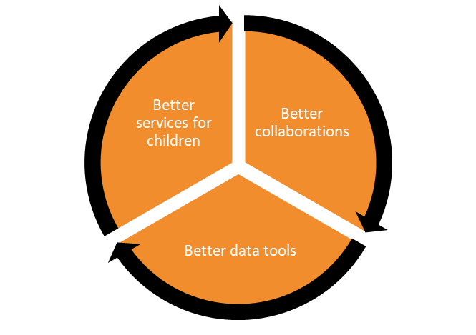

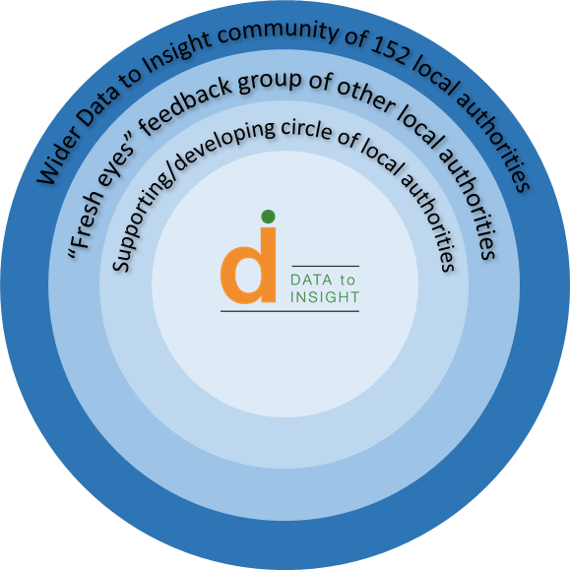

What is this document?
The D2I data service diagnostic is a way to bring together colleagues locally within a council, to explore how they work with data, how their data and intelligence processes fit together, where they don't work, and how they might change. It steps through this to arrive at an action plan and/or development goals determined by participants.
Our projects are collaborative, and our service exists to facilitate that collaboration, help good practice spread across regional boundaries, and ensure essential data work receives the support it needs. As such, we trust LAs and we don't tell LAs what to do. The D2I service diagnostic isn’t an inspection; views are represented as stated by LA employees, unless explicitly noted otherwise. LAs are all different, and there is no one best way to do everything.
This document provides a framework for a full day workshop with local stakeholders to interrogate their local data practice in relation to children’s safeguarding services, and identify key challenges and further work areas. The outputs from the session should then be formalised in a written report which serves as a point of reference for stakeholders after the workshop.
The report produced from the service diagnostic can have several audiences, among them Children’s Services colleagues at the LA, their local partners, and supporting colleagues within central government. The most important audience is the group of local professionals who will decide what to do in response to the report’s findings, and who helped to produce them.

Patterns of data service delivery
There is no one right way to deliver a local data service in support of children’s safeguarding work. Some of the most important work relating to data, in any organisation, consists of designing and monitoring the mechanisms by which data work happens, and ensuring that these fit well with wider business needs. Sometimes this is a question of lightly tailoring a popular approach; in other cases the task is more complex. As data professionals, we rarely get to choose the shape, strategy, or ambition of our organisation. We must fit our operations to the wider context.
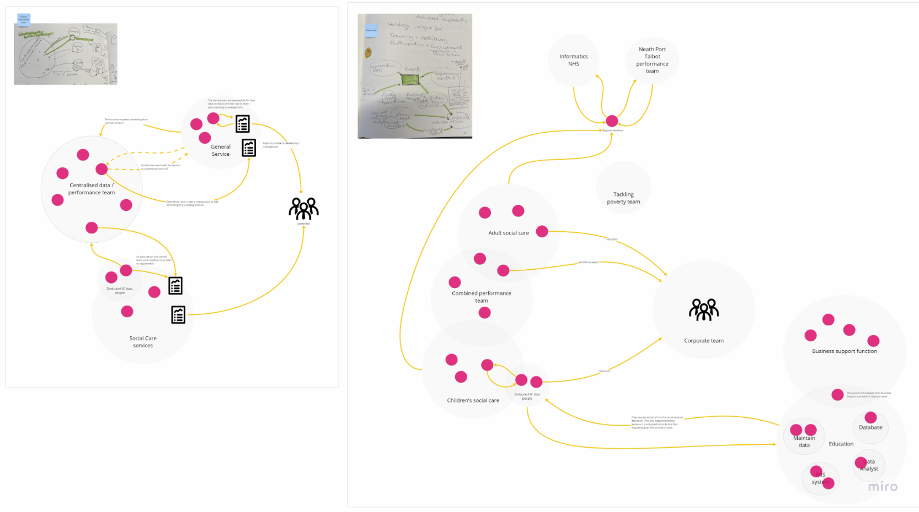
Here are two examples of typical data service configurations in local authorities. Bear in mind that these are neither comprehensive in themselves, nor the only models which work. On the left we see a corporate performance function supporting distinct service areas with their data work; on the right we see a performance team shared across adults’ and children’s services. Of course, both maps contain further details and peculiarities.
Source: Scoping a Professional Development Framework for Social Care Analysts, Social Finance / Social Care Wales, 2023
https://socialcare.wales/cms-assets/documents/scoping-a-professional-development-framework-for-social-care.pdf
The key organisational models to add to these are those where (a) the only “dedicated” CSC data people all sit in the corporate team, (b) all the data work happens within the safeguarding service, and there’s minimal interface with any other services, and (c) a significant portion of the work is held within a corporate ICT function rather than a corporate performance/data function.
The above maps and descriptions are all only partial; the most obvious question they raise is how much of the management information system analysis and reporting infrastructure is owned and maintained by the service areas mapped here, and how much is owned by an ICT function which isn’t mapped. This is a critical point of distinction for a lot of English Local Authorities when comparing practice infrastructure, and we will include these functions in our own service diagnostic, and it impacts analytical practice significantly – some CSC-embedded data people have full control over their systems and tools, using IT support only for hardware support and network security; at the other extreme, some have to log an IT call to get a single field added to a data report, or rely on the MIS supplier for almost all system maintenance.
The purpose of our data service diagnostic isn’t to assess a given service against the above models; it’s to understand how the service currently works, what the organisation’s goals are, and how well the two align. From there, it’s possible to agree objectives to improve the service, i.e. to work towards a better fit between data service and business needs.
D2I Service Diagnostic template materials
When mapping a local system it’s useful to begin with a basic categorisation of the different functions you would expect to encounter – both to simplify your map, and to ensure you don’t miss key elements. Similarly, it’s useful to have a basic categorisation of the different business areas you might expect to see in a local authority.
Neither of these should be used as exclusive or limiting lists when performing a service diagnostic; if you meet something new or unexpected during system mapping, you can change your map.
A reasonable functional categorisation might include:
- Front line services and management
- Corporate performance and policy
- Internal (to the CSC service) performance and policy
- MIS maintenance and development
- Reporting maintenance and development
- Data analysis

A business area categorisation might include:
- External suppliers X/Y/Z (distinguishing between separate suppliers e.g. MIS, outsourced IT, cloud hosting)
- Corporate team X/Y/Z (distinguishing between separate areas e.g. IT usually separate to performance)
- “Internal” (to the CSC service) team X/Y/Z (distinguishing between separate teams e.g. data/systems)

The mapping is only one stage of the diagnostic, but it’s an important one.
The below sections explain how to run a full data service diagnostic using D2I’s approach, and how to write up the outputs to support your organisation in achieving positive change.

Performing a data service diagnostic
D2I’s work is free and open to colleagues in every local authority in England. Our projects are collaborative, and our service exists to facilitate that collaboration, help good practice spread across regional boundaries, and ensure essential data work receives the support it needs. As such, we don't tell LAs what to do. In any case, LAs are all different, and there is no one best way to do everything.
The D2I data service diagnostic is a way to bring together colleagues locally to explore how their data and intelligence processes work, where they don't work, and how they might want to change them. It steps through this to arrive at an immediate action plan determined by participants.
The goal of the diagnostic is not to arrive at a perfect system map or document, but to arrive at actionable insight which will benefit the organisation – and which the organisation feels able to address. Any and all parts of the process can be modified in service of that goal.

Before the session:
- Make an information-capture template (see screenshots below) to a clean area of a “whiteboard” or other collaborative space. Popular tools for this kind of work include Miro, Microsoft Whiteboard, and pen-and-paper/post-it-notes. Each headed section of the template should be a separate page or screen.

- Meet with the DCS (or relevant local safeguarding service leader) before the session to identify:
  - Complete the "What the DCS sees now" section to the left of the template, outlining the DCS' perspective of how things are, where their key frustrations or concerns arise, and what they hope to achieve by holding a service diagnostic session.
  - Complete the "Who needs to be involved" section to the right, identifying the key people who need to attend the session, and which sections of the session they need to attend.
  - Agree who in the LA will arrange the session and ensure that attendees are available to contribute.
  - NB: this must be a local safeguarding service leader, not a data or performance professional. The goal at this stage is to capture the understanding, intentions, and perspective of the senior user of the data service, not the provider.

- Set a date when everyone can attend, and make arrangements for suitable facilities.

During the session (morning):
Follow the mood of the room. As facilitator, you need to keep an eye on the goals you're hoping the group will achieve, but also give them space to step away from the template where it’s useful. The template is there to facilitate a journey towards shared goals, not to be completed for its own sake.
With that said, an example session might look like the below:
- Ensure the right people are in the room, and agree a shared purpose based on the agenda laid out in the sections to the right (if you need, you can amend the agenda at this point to fit the agreed shared purpose; you can also agree how you might ensure you represent the views of any “missing” colleagues).

- Gather any initial ideas, comments or concerns in the "Ideas to hold onto for later" section to the right, so that they're not lost during the set agenda.

- Use the "How we see the key issues today" section to confirm/expand the DCS initial view, and understand what the existing process looks and feels like to participants, where the best things happen, and where the biggest pain points occur.

- Use the "Data system mapping" section to draw the existing data processes in a way that makes sense to participants and highlights key areas for attention.

- Use the "Key people and relationships" section to draw the existing organisational roles and relationships in a way that makes sense to participants and highlights key areas for attention.
It may be that things flow together, and you cover off, say, step 5 as part of step 4.

During the session (afternoon):
Review where the morning session ended and how best to proceed. In the standard plan, the below steps may be useful. However, your conversation may have taken you in a different direction; it may be better to focus on one or other, or to dig into specific elements within key problem areas.
- Agree what participants want the system and processes to deliver - this may be particular data outputs, functional capabilities, insights or time/cost/quality levels - in the "Target outputs (goals)" section.

- Use the "Service model (vision)" section to attempt to draw out an arrangement of existing and/or locally plausible resources and capabilities which will better deliver the desired outputs and/or better equip the LA to approach those outputs (this may take several tries to get right, and participants shouldn't feel bound to their first idea; it may be useful to draw up several different possible models).

- Ensure you leave time at the end of the session to use the "Immediate actions (plan)" section to agree who will do what next, so that the outputs of this exercise are not lost when the session ends.

After the session:
Write up a formal report detailing findings from the session. This can take whatever form seems best to participants and/or the facilitator, as long as it serves as a useful shared record of the work. At a basic level, it might contain the following sections:
Contributors
- Details of each role and individual contributing to the session, as well as any roles or individuals not present whose views would be relevant.
- Typically this will involve a brief blurb introducing the DCS/senior leader, the other members of the leadership team, the technical support colleagues and their places in the LA, and the facilitator.
What the DCS sees now
- This is really the opening statement of the issues at play in the LA, or the reason for conducting the service diagnostic.
- Typically this will include a very brief summary from a leadership perspective of the various strengths and challenges in the service, as well as some idea of what the DCS hopes to achieve by scrutinising this area.
System mapping
- Best presented diagrammatically, this is the core output from the morning session, demonstrating the organisational.
- This will typically show the distinct/related business areas, the roles or functions in relation to those, the resource/capacity of these, and the identified gaps or challenges in the system as it is.
- This should be supplemented with brief commentary under headings like “system overview” (explaining how the system currently functions, why it is designed as it currently is, etc.), “what currently works well?” and “where are the key issues?”
Target outputs / goals
- The key output from the afternoon, this organises and explains the various things that the LA colleagues want to achieve to improve their local system.
- This might include a diagram or other image followed by subheading sections discussing each of the key areas for attention.
- This might include a “next steps” section agreeing what people will do next in pursuit of these goals.

The template sections in text form, for copying to your own template software/media
Before the session (1):
What the DCS sees now:
Before the session (2):
Who needs to be involved:
DCS for kick-off and problem definition (and as much of the rest of the day as they’d like to spend)
Select heads of service (by recommendation/volunteering) for at least the morning
Data and performance/BI (who provide service leads with data and intelligence support) all day
IT/MI leads (who manage the data infrastructure and reporting outputs, if different) all day
A facilitator
Morning (0)
Ideas to hold onto for later
Morning (1)
How we see the key issues today:
Where the best things happen:
Where the big pain points are:
The problems we should solve:
Morning (2)
Data system mapping:
Resources:
What they do:
How they connect:
Morning (3)
Key people and relationships:
Afternoon (1)
Target outputs (goals):
General capabilities:
Specific products:
Afternoon (2)
Service model (vision):
Afternoon (3)
Immediate actions (plan):

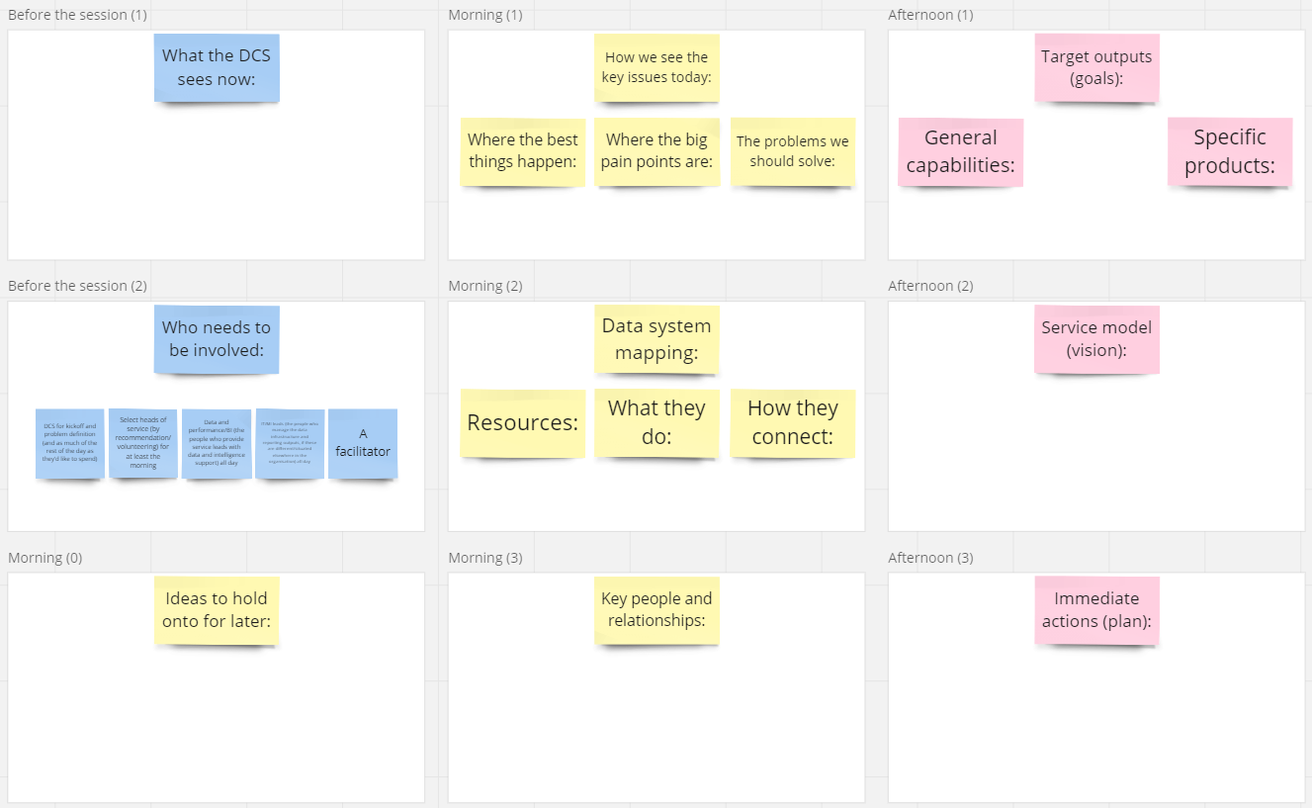
Screenshots of the template sections (example layout)
Contact: datatoinsight.enquiries@gmail.com

